LAB SESSION 7
Programming Exercise:
Question 1: Create a base class Vehicle with a method move() that prints "Vehicle is moving". Derive a class Car from Vehicle and override the move() method to print "Car is moving".
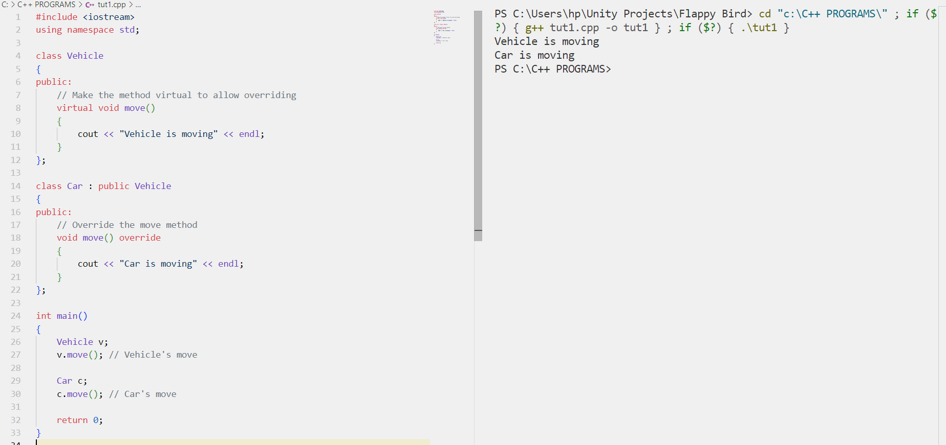
Question 2: Constructor in Derived Class Create a base class Person with attributes name and age. Create a derived class Student with an additional attribute studentID. Initialize these attributes using constructors.
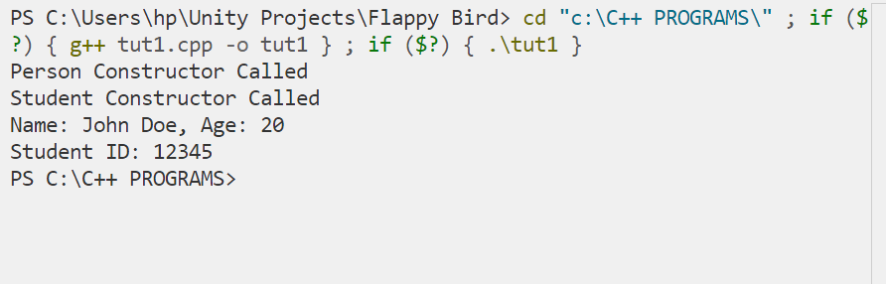

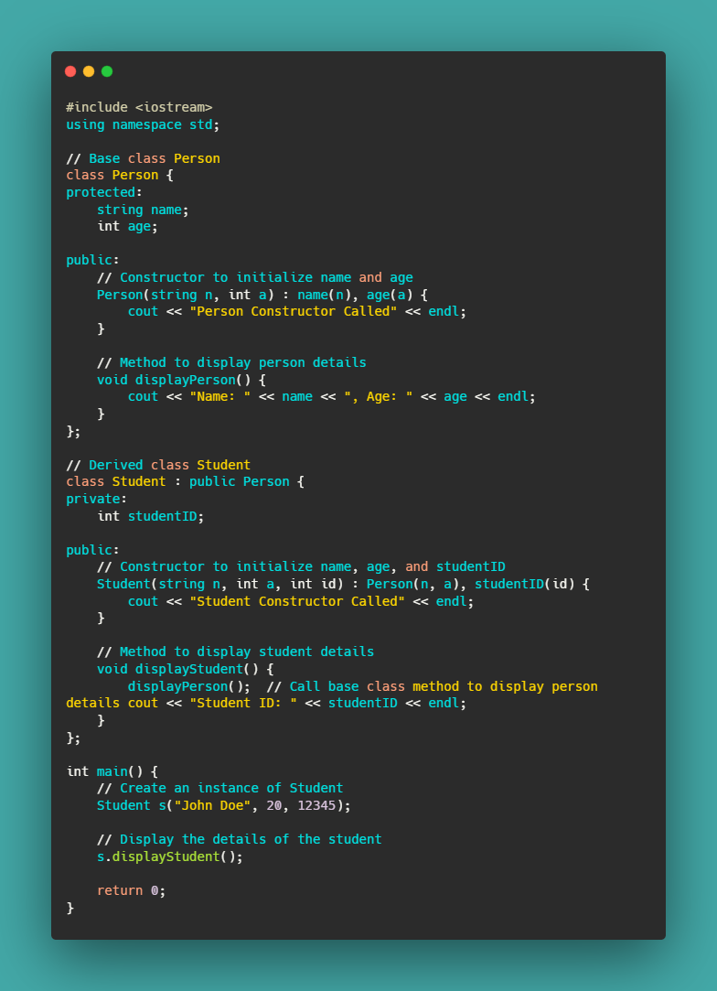
Question 2: Constructor in Derived Class Create a base class Person with attributes name and age. Create a derived class Student with an additional attribute studentID. Initialize these attributes using constructors.
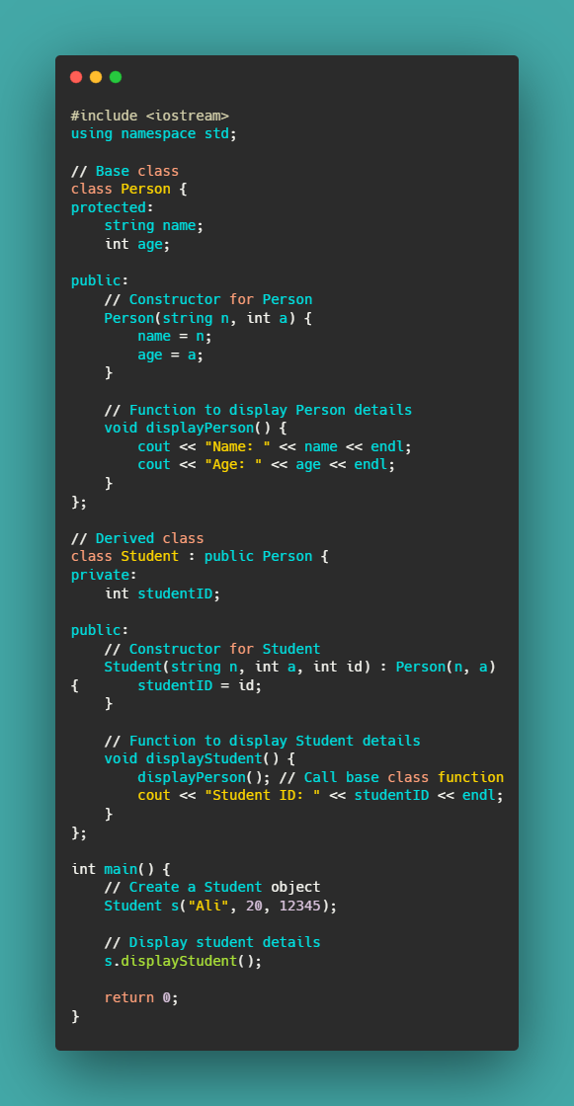
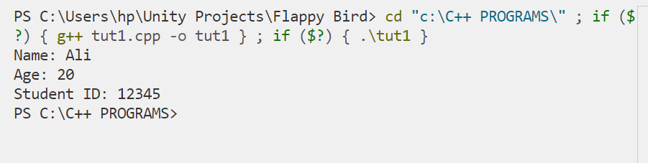
Question 3: Method Overriding Create a base class Shape with a method draw() that prints "Drawing Shape". Create derived classes Circle and Square that override the draw() method to print "Drawing Circle" and "Drawing Square", respectively.
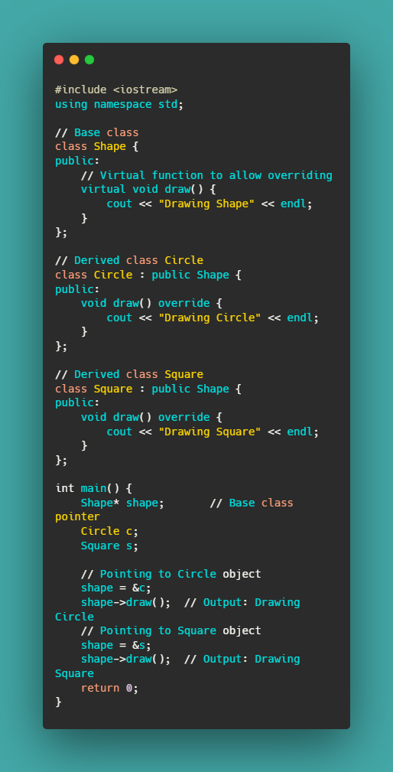
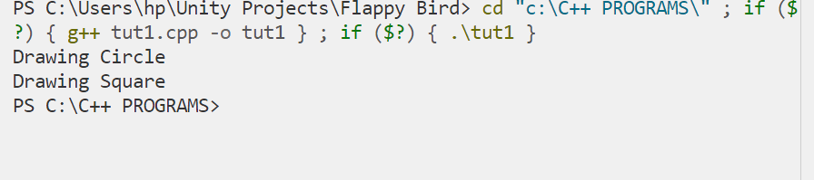

Question 4: Access Specifiers Create a base class Base with a private attribute privateVar, a protected attribute protectedVar, and a public attribute publicVar. Create a derived class Derived and demonstrate access to these attributes. Write your observations.
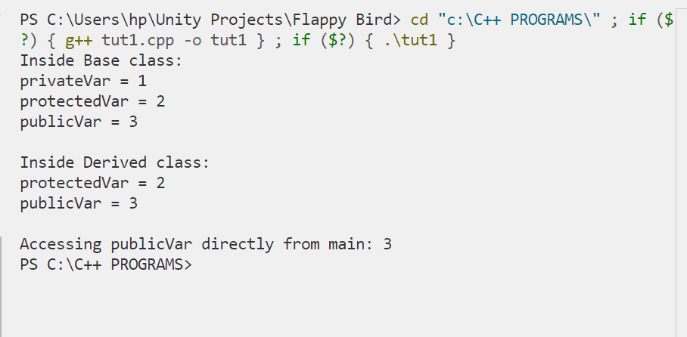
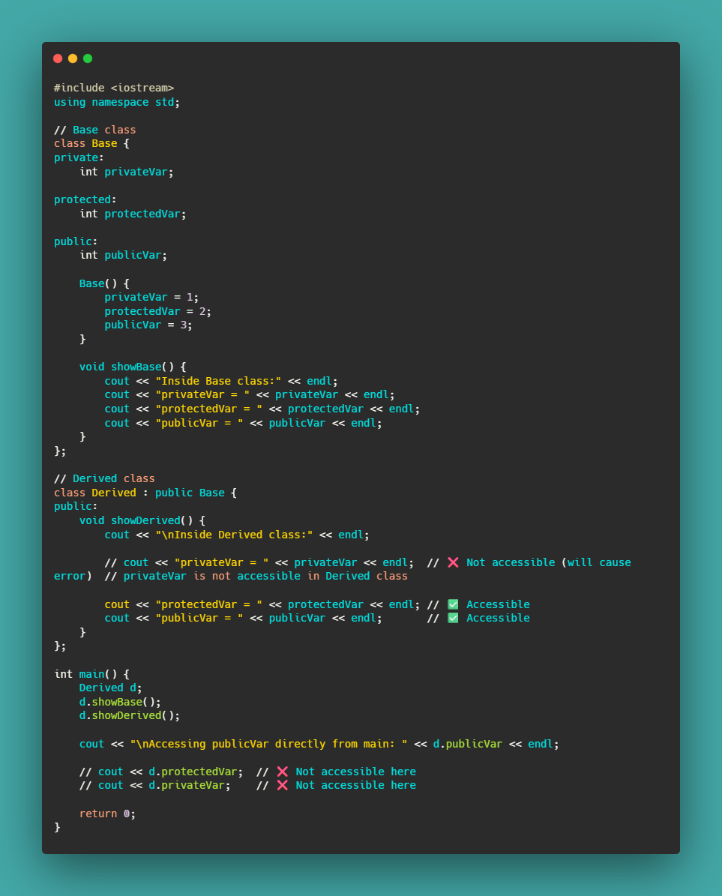

Question 5 You are required to create a C++ program that demonstrates the concept of inheritance.Consider the following requirements:
